Candidate’s Name:……………………………………………………………………………………………………………………………………….........

THE PRESIDENT’S OFFICCE
REGIONAL ADMISTRATION AND LOCAL GOVERNMENT
ARUSHA REGION FORM TWO MOCK EXAMINATION
INFORMATION AND COMPUTER STUDIES
TIME: 2:30 Hours May 2023
INSTRUCTIONS
1.This paper consists of section A, B and C with a total of ten (10) questions
2. Answer ALL questions in section A, B and C
3. Section A carries 15, section B carries 60 marks and section C carries 20 marks

SECTION A: (20 MARKS)
Answer ALL questions in section
- Choose the most correct answer for each of the following items and write its letter in the space provided.
- The Analytical engine developed during first generation of computers used_______
- RAM C. Cards
- Floppies D. counter wheel
- One of the following properties of a central processing unit (CPU) is measured in gigahertz (GHZ)
- Speed C. Temperature
- Volume D. cost
- Memory that loses its contents when power is lost is
- Volatile C. random
- Static D. non-volatile

Page 1 of 5

- Language were used in first generation computer
- Assembly language B. High level language

- Machine language D. None of the above
- Running multiple programs at the same time is called______
- Multitasking C. Single tasking
- Fore ground tasking D. Symmetric
- By default an excel workbook consist of ______sheets
- 1 B. 3
- 2 D. 4
- Which of the following software is not supporting user to carry specific task?
- Adobe photoshop C. ubuntu
- Desktop publication D. Presentation
- The network topology that use a central controller or hub is known as
- Star C. ring
- Mesh D. Bus
- The following are the features of the Microsoft word except
- Synonyms C. footer and header
- Page insertion facility D. statical functions
- A person who uses the computer skills to gain access of information illegally is known as______
- Hacker C. programmer
- Analyst D. Administrator

Page 2 of 5
- Mach each item from column A with its corresponding item in column B
COLUMN A | COLUMN B
- They are used to change letter from the upper case to lower case and vice versa  - Turn on the numeric keypad for numeric data entry  - Used to move the text cursor at a set of intervals on the same line eg. 100mm,20mm etc  - It create a gap between word when typing  - Used to fix symbol like !,#,$,% | - Tab  - Typing key  - Column  - Enter key  - Active cell  - Mouse pointer  - Space bar  - Rows  - Shift  - Num lock  - Caps lock  - Delete  - Page number

- For each of the following statement , write TRUE if the statement is correct or FALSE if the statement is not correct
- A wide area network (WAN)is a type of network which cover an area like a school or a building ___
- UNIVAC is the analog computer created during the first generation of computer _______
- A window is simply a rectangular area that can contain a document, program or message _________
- With word processor it is not possible to print multiple copies of at once______
- Horn , journal and whistle are traditional ways of disseminating information
SECTION B: (60MARKS)
Answer ALL questions in section.
- Why do most of the organization in the society opt to use computers in their daily activities? Briefly explain by giving five points
- a) By giving two examples, briefly explain the importance of application software are used at schools.
b) Explain three hardware criteria to consider when selecting a computer

page 3 of 5
6. a) Why does operating system considered as the main program in the computer?
b) Explain three steps to create a new folder on the desktop

c) Give three reasons why a mobile phone is regarded as a computer
7. a) Explain the meaning of the following terms as used in word processing
i) Header
ii) Page break
iii)bullets
b) John has finished typing the letter. Print preview shows that it is more than one-page long. State two ways in which the letter could be made to fit on one page
8. The JOSTIBA company which deals with home theater system and stationeries has four offices in the three different cities; Arusha , Dodoma and Dar es salaam.The manage decided to connect all these offices thought a network. However, he does not know the type of network to use
a) Briefly explain to the head of department three types of computer network you know and suggest the proper types of network to be established
b) Provide two advantages and two disadvantages of the types of network suggested in part (a)
9. a) Ms Excel can be used for several purpose. Mention five of them
b)Observe the following worksheet and answer the question that follow
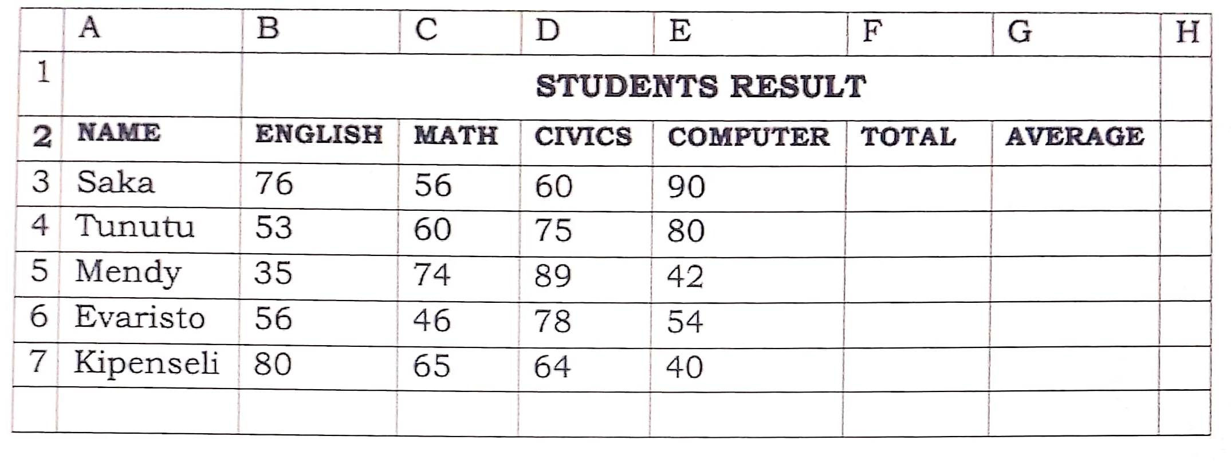

Page 4 of 5
- Write two formatting features used in the first row______
- Write down the formula to display the total marks of tunutu_____
- Write down the function to find the average of mendy _____
- Write down the function to calculate the maximum marks in civics_______

SECTION C: (20 MARKS)
Answer ALL questions in section
10. Briefly describe any five types of physical network topologies

Page 5 of 5

